



**ICTAK LEARNER TRACKER**

**Submitted By**

AMANA HUSSAIN

ANUSHA ANIL

NEETHU S NAIR

PREMY PRASAD

VAISHAK C KRISHNAN

CERTIFIED SPECIALIST IN FULL STACK DEVELOPMENT (MEAN)

[Kerala Knowledge Economy Mission (KKEM](https://retail.ictkerala.org/course/view.php?id=231))

**ICT ACADEMY OF KERALA**

**JULY 2022**

**ICTAK LEARNER TRACKER**

**ABSTRACT**

The project is entitled as ICTAK Learner Tracker. This project developed under the platform of Angular as front end, NODEJS as back end and MongoDB as database. The main aim of this project is leaner tracker, and it is done by Trainer head and Placement officer. And the process is controlled by Admin. The admin should have the overall control over the website with CRUD operation on Training head and Placement officer. Admin can also view the details added by Trainer head and Placement officer.

**INTRODUCTION**

ICTAK Learner Trackers a simple yet powerful option that allows you to quickly plan, structure, and organise training, especially to create a long-term training program. In essence, the learning track is a series of courses that creates a linear flow of what your users have to learn and should enable the Training Head to view the status of each student enrolled with ICTAK.

**PROJECT OBJECTIVE**

The main objective of this system is to design or develop a Learner tracking portal for ICTAK for maintaining course details, Learner information, Training head and Placement officer. Users can use this system from anywhere to find out about the details of the learner. This platform must enrol the trainers and enable them to create and evaluate the exams and analysis the feedback of students. It consists of an Admin login along with Trainer and Placement officer login. Admin have the overall control over the website with CRUD operations on Training Head & Placement Officer

**TEAM MEMEBERS**

* AMANA HUSSAIN
* ANUSHA ANIL
* NEETHU S NAIR
* PREMY PRASAD
* VAISHAK C KRISHNAN

**FLOW CHARTS**

1. **Admin**

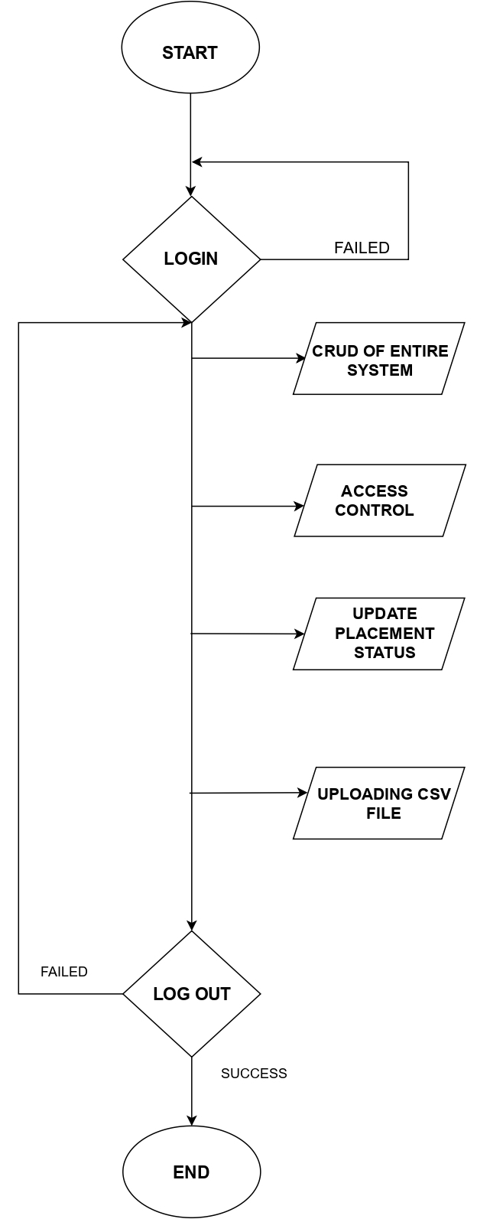

1. **Training Head and Placement officer**

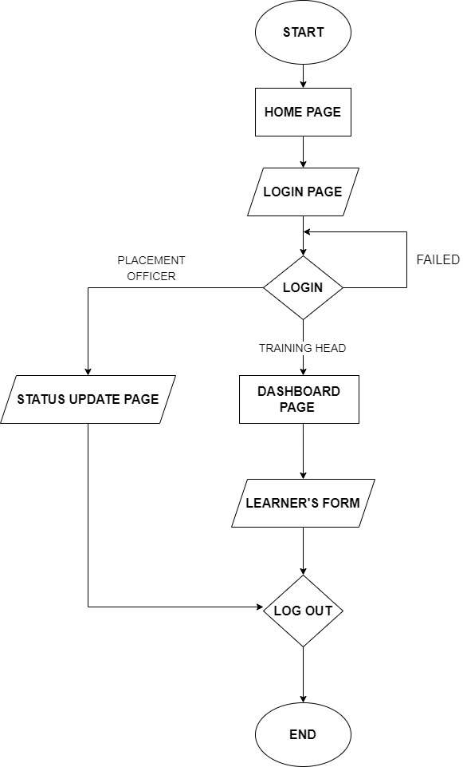

**DATA FLOW DIAGRAMS**

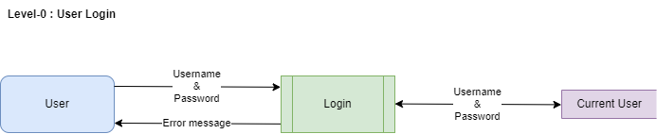

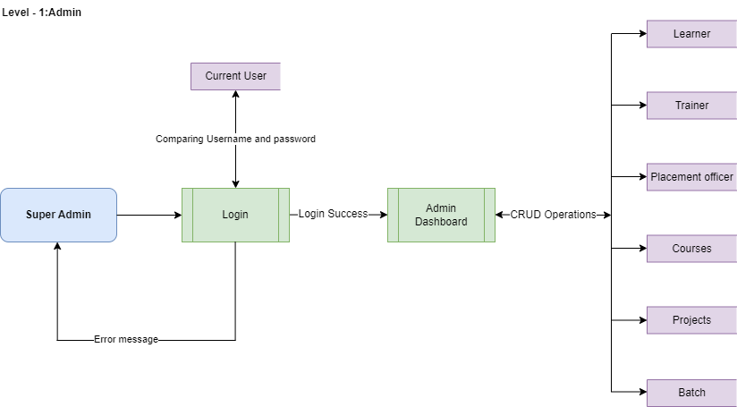

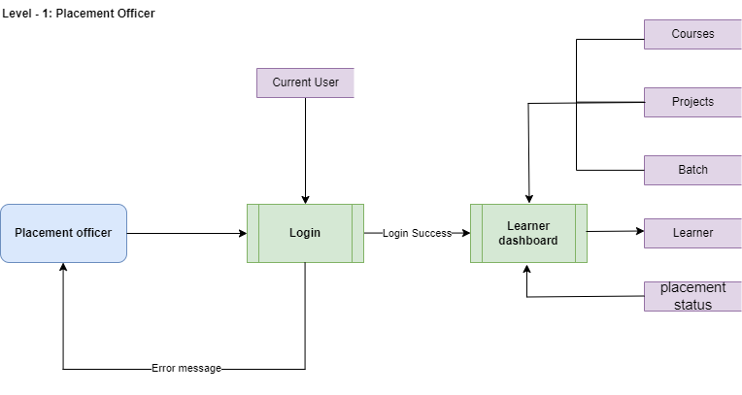

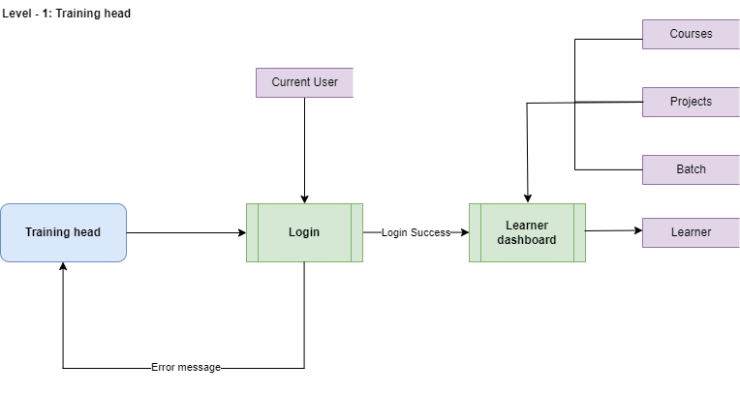

**END**